# A:\CBHE-factori\aa-starter\Factori_soumis\communication\logo\Logo Factori 4.0.png

# From Automation and Control Training to the Overall Roll-Out of Industry 4.0 Across South-East Asian Nations

# (ASEAN FACTORI 4.0)

**PROJECT No. 609854-EPP-1-2019-1-FR-EPPKA2-CBHE-JP**

**Seminar for Chulalongkorn University Students in the new designed courses** **(CPP-Seminar 2) on November 7, 14, 2022**

**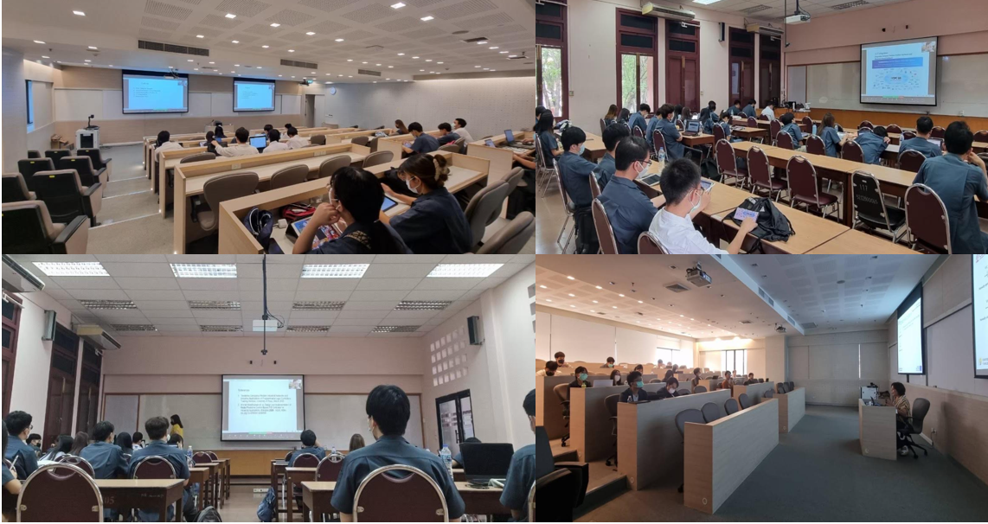**

**Master and Bachelor students**

This highly informative and practical programmable logic controllers (PLCs) seminar had been carefully crafted to enhance the understanding and skills of students as a part of Industrial Automation Course (B.Eng. Electrical Engineering), Process Dynamics and Control Course (B.Eng. Chemical Engineering), and Instrumentation in Chemical Process Course (M.Eng. Chemical Engineering). The instructors are Prof. Paisan Kittisupakorn PhD. from Department of Chemical Engineering, Prof. David Banjerdpongchai PhD. from Department of Electrical Engineering, and Instructor Sirikanya Singcuna from Department of Chemical Engineering.

Electrical Engineering and Chemical Engineering students had the opportunity to explore the fascinating history of programmable logic controllers (PLCs), gaining invaluable insights into their evolution and significance within the realm of industrial automation. By understanding the historical context, they would develop an appreciation for the rapid advancements in PLC technology, which paved the way for the cutting-edge solutions found in Industry 4.0.